Airlines Analysis Dashboard
Step1: Clean and Transform Data
- Based on data set have to analyse the data by using Power BI.
- First, we have to get the data by clicking the get data option in power bi and load the data.
- After load the data we have to clean the data by clicking the Transform data to power query.
- By using the Power query, we have to clean the data and transform the data.
- By using the power query, we have to remove the null values and replace with “0” or “Unknown”.
- By taking the data, we have to change the data type like Date, time, Flight_ID, profit,Delay_mintus as like decimal number, Date, whole number
- In data set we have different columns in that Flight_Id has duplicates have to remove by clicking the Top Header and remove Duplicates
- In this project I have add new columns in Airlines Main Data as main table I have calculated like revenue Category, Delay category, profit, Route
- And also, I have divided the Date as different columns as year, month, day, month Name.
- In this project I have create the some more tables for star schema like Fact table and dimension table based on the Main table.
- For the fact_table I have created as Fact_Flights and for Dimenison tables I have created different dimension like Dim_Location, Dim_Services, Dim_Airline,Dim_Date,Dim_Customer.
Step2: Star Schema and dimension table
- Based on the main table I have created the Fact table and Dimension table by Duplicate the Main table
- In fact table coloums will present like
- FlightID
- Date
- Airline
- Source
- Destination
- Arrival_Time
- Departure_Time
- Durtion_Mintues
- Distance_Km
- Price
- Stop
- Class
- Booking_Channel
- Customer_age
- Customer_gender
- Bagging_Kg
- Route
- Profit
- For Dimension Table:-
DimDate:-
- Date
- Day
- Year
- Month
- Monthname
Dim_Loctaion:-
- Route
- Source
- Destination
Dim_Sevices:-
- Class
- Booking_Channel
- Meals
- Seat_Type
Dim_Customer
- Customer_Age
- Customer_Gender
Dim-Airline
- Flight_Id
- Airline
- After this creation of table, I have done the Model view I have taken as Fact_ table and Dimension tables to get relation ship like one to many, many to many, many to one relationship based on the data I have done
- In my project I have taken Relationship
- Dim_Airline Fact_Table as one to one relationship.
- Dim_Loctaion Fcat_Tbale as many to many relationships.
- Dim_Customer Fcat_Tbale as many to many relationships.
- Dim_DateFcat_Tbale as many to many relationships.
- Dim_Services Fcat_Tbale as many to many relationships.
Step3:- DAX and Measures
- Based on the Data set I have calculated the Dax and new columns has been added in main table
- Profit (assumption-based): -
Profit = [Price] * 0.2
- Delay Category: -
IF([Delay_Minutes] = 0, "On Time",
IF([Delay_Minutes] <= 30, "Minor Delay", "Major Delay"))
- Route: -
Route = [Source] & " - " & [Destination]
- Revenue Category: -
Revenue Category =
IF([Price] < 5000, "Low",
IF([Price] < 10000, "Medium", "High"))
Measures:-
- Total Revenue = SUM(Fact_Flights[Price])
- Total Profit = SUM(Fact_Flights[Profit])
- Avg Price = AVERAGE(Fact_Flights[Price])
- Total Flights = COUNT(Fact_Flights[Flight_ID])
- OnTime % =
DIVIDE(
CALCULATE(COUNT(Fact_Flights[Flight_ID]), Fact_Flights[Delay_Minutes]=0),
COUNT(Fact_Flights[Flight_ID])
)
- Avg Rating = AVERAGE(Fact_Flights[Rating])
- Revenue per km = DIVIDE (SUM(Fact_Flights[price], SUM(Fact_Flights[Distance_KM]))
- Revenue per Flight = DIVIDE ([Total Revenue], [Total Flights])
- Revenue per Age Group =
DIVIDE(
[Total Revenue],
DISTINCTCOUNT(Fact_Flights[Customer_Age])
)
- Revenue Female =
CALCULATE(
[Total Revenue],
Fact_Flights[Customer_Gender] = "Female"
)
- Revenue Male =
CALCULATE(
[Total Revenue],
Fact_Flights[Customer_Gender] = "Male"
)
- Profit Margin % =
DIVIDE([Total Profit], [Total Revenue])
- Load Factor % =
DIVIDE(
SUM(Fact_Flights[Baggage_KG]),
COUNT(Fact_Flights[Flight_ID]) * 30
)
- For Date_Diemnsion measures
- Monthly Revenue =
CALCULATE(
[Total Revenue],
VALUES(Dim_Date[Month])
)
- Previous Month Revenue =
CALCULATE(
[Total Revenue],
DATEADD(Dim_Date[Date], -1, MONTH))
- MoM Growth % =
DIVIDE(
[Total Revenue] - [Previous Month Revenue],
[Previous Month Revenue]
)
- Year over year Growth
YoY Growth % =
VAR PrevYear =
CALCULATE([Total Revenue], SAMEPERIODLASTYEAR(Dim_Date[Date]))
RETURN
DIVIDE([Total Revenue] - PrevYear, PrevYear)
Based on the data I have find the Dax and Measures
Step 4 : - REPORT VIEW
- Executive Overview
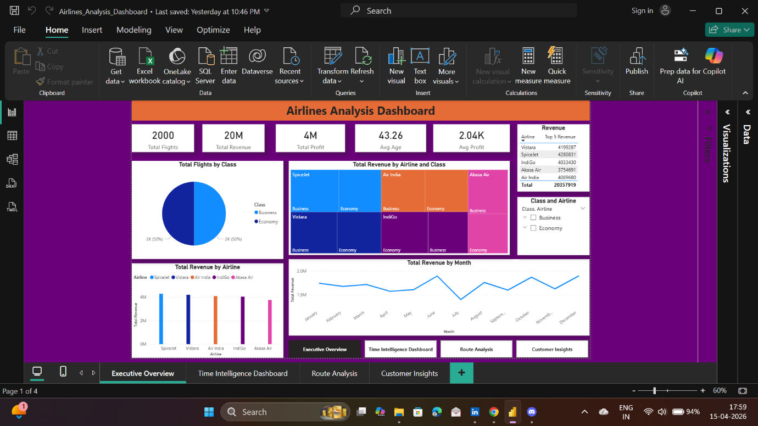
2.Time Intelligence Dashboard
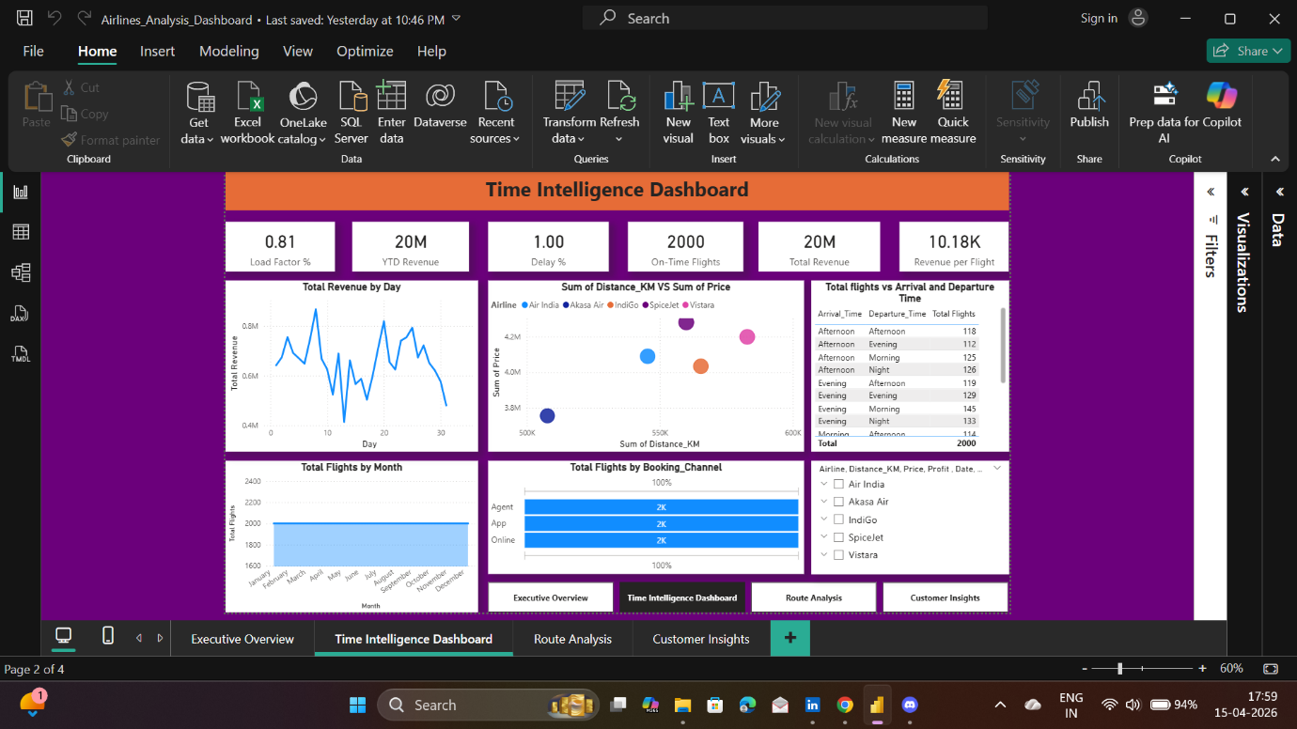
3.Route Analysis
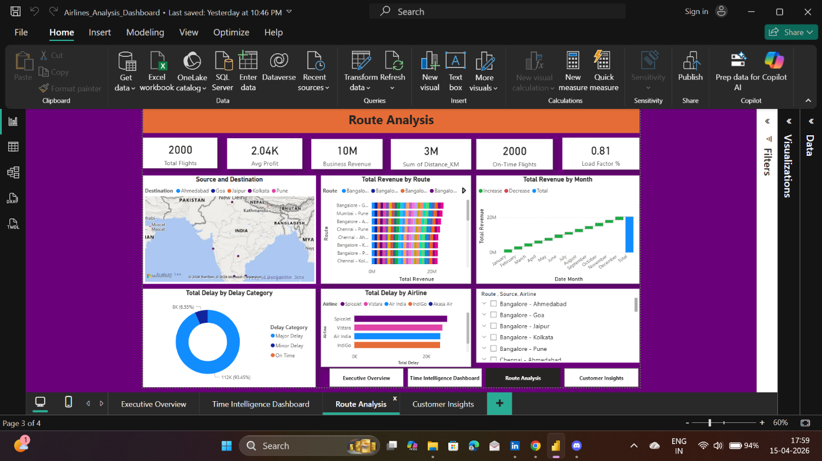
4.Customer Insights
